## ****Phase IV: Database Creation and Configuration****

### Objective:

Create an Oracle Pluggable Database with the correct naming convention and set up **Oracle Enterprise Manager (OEM)** for monitoring.

## Step 1: Naming the Database

Follow the required format:

GrpName_StudentId_FirstName_ProjectName_DB

GrpA_24918_sheja_moviesMS_db

**Password:** 123

## Step 2: Create the Database in Oracle (XE)

### I use the following script( SQL Developer):

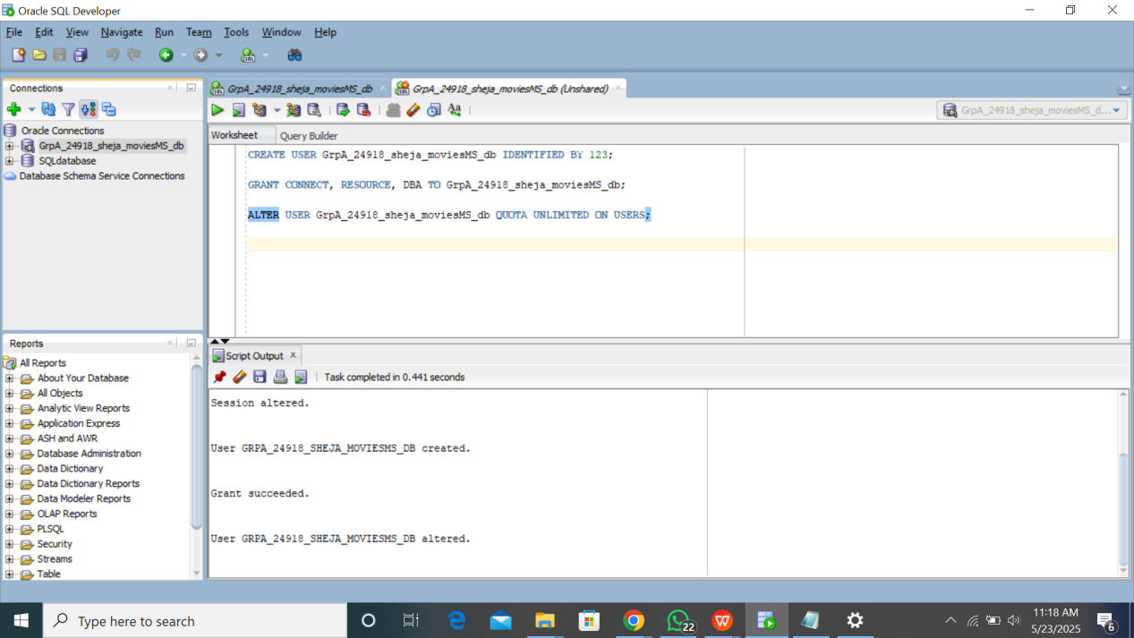

## 🧭 Step 3: Oracle Enterprise Manager (OEM)

Oracle XE comes with **OEM (EM Express)** which can be accessed at:

<https://localhost:5500/em>  
  
